Shopaa

UI Prototype

Version <1.0>

Revision History

| **Date** | **Version** | **Description** | **Author** |
| --- | --- | --- | --- |
|  |  |  |  |
|  |  |  |  |
|  |  |  |  |
|  |  |  |  |

Table of Contents

**I. Homepage screen** **5**

**II. Select store screen** **7**

**III. Order screen** **9**

UI PROTOTYPE

# Homepage screen

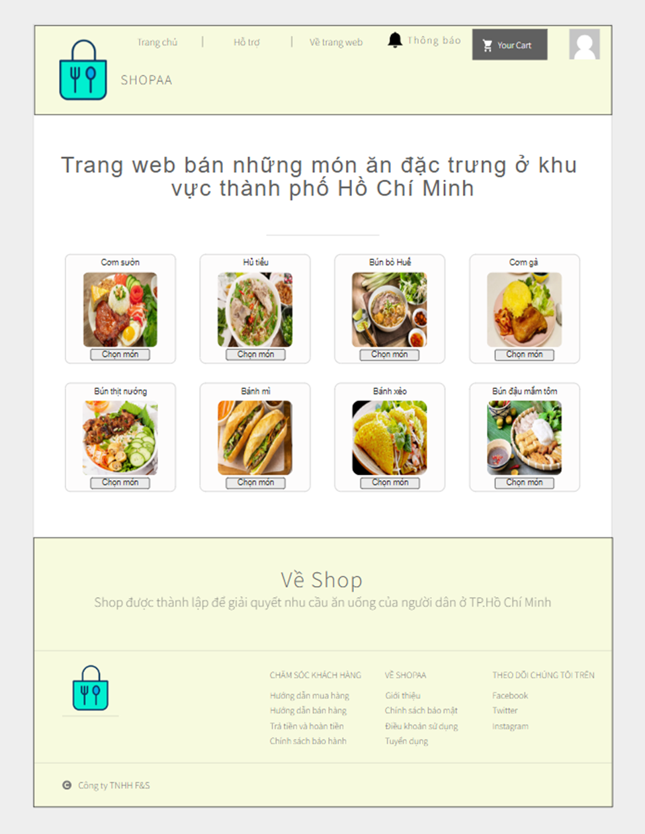

When clicking the shop link, users will be brought to the homepage. On the top of the homepage, there is an icon of the website.

On the top of the page, to access again to this page, user can click “Trang chủ”. If you don’t know how to use the website click “Hỗ trợ”, there are a lot of description can be helpful. If you want to know more about the owner or website click “Về trang web”. The bell icon will tell you when notifications come. Click the avatar icon will bring you to log in screen if you haven’t signed in yet or you will be brought to account management screen

Title “Trang web bán những món ăn đặc trưng ở khu vực thành phố Hồ Chí Minh” is a short description for the website and administrator can change it

The homepage screen display some typical dishes, example 8 dishes in the picture, users click “Chọn món” for the food which want to eat, users will be brought to select store screen which the store sell

On the bottom of the page, first is “CHĂM SÓC KHÁCH HÀNG” which means customer care. There are buy food tutorials, sell food tutorials, return & refund and Warranty Policy. Second “VỀ SHOPAA” is about website information included Introduction, Privacy Policy, Terms of use and Career. Last is fanpage of the website in some social media

# Select store screen

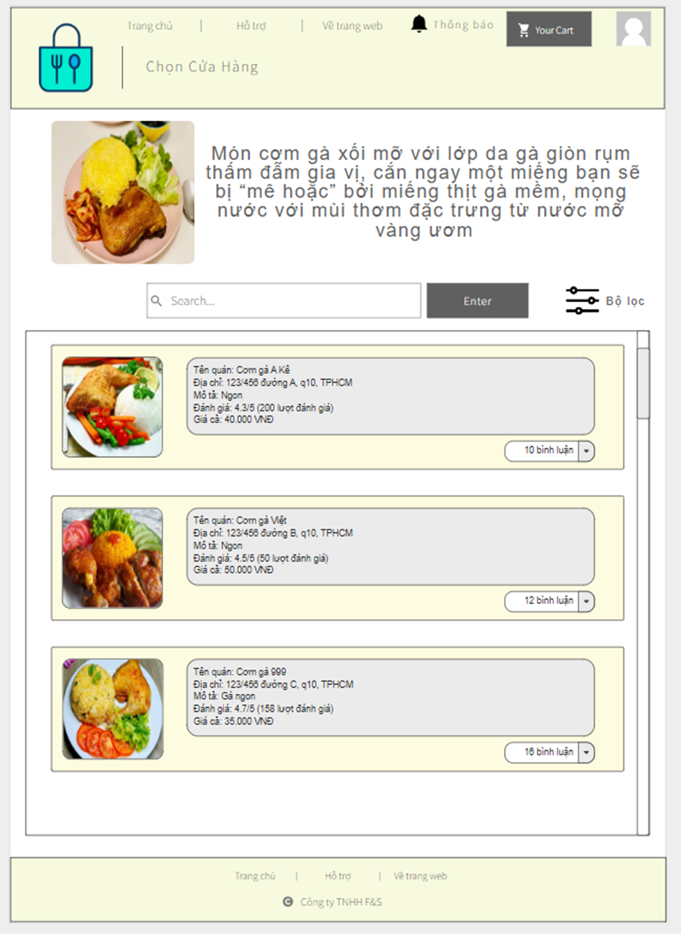

When users choose a typical food, they will be brought to this page. In this page, the first picture is the default picture and general description about the food.

In searching bar user can type the name of the store sell that food or user can click filter icon to find what they want

In scroll list box contains posts of different stores.

In a post there is a picture of food the store provides, description about the post included name of store, address, food description, rate, price and list of comments. If the user want that store, click the post and the post will be added to cart or they can leave comments by clicking the comment block

# Order screen

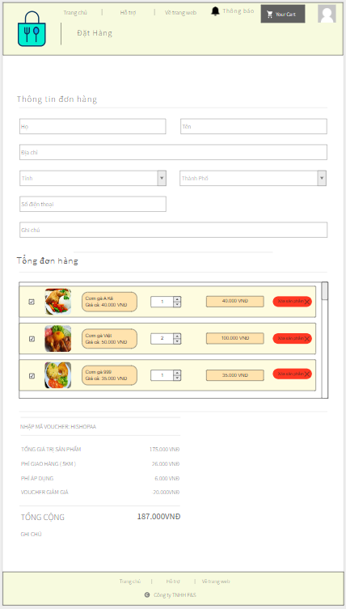

After clicking the order in the cart, users will be brought to the order screen. They need to fill the information, check the cart again and can select which to order. After selecting, the page will show the total price

Addition, in the “NHẬP MÃ VOUCHER”, users will get it in the event or from administrator and the discount will be based on that voucher